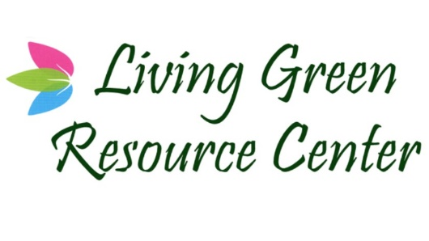

**DISCLAIMER**

LIVING GREEN RESOURCE CENTER  WILL NOT BE LIABLE FOR ANY DAMAGES OF ANY KIND ARISING FROM THE USE OF THIS SITE OR FROM ANY INFORMATION, CONTENT, MATERIALS, PRODUCTS (INCLUDING SOFTWARE) OR SERVICES INCLUDED ON OR OTHERWISE MADE AVAILABLE TO YOU THROUGH THIS SITE, INCLUDING, BUT NOT LIMITED TO DIRECT, INDIRECT, INCIDENTAL, PUNITIVE, AND CONSEQUENTIAL DAMAGES, UNLESS OTHERWISE SPECIFIED IN WRITING.

CERTAIN STATE LAWS DO NOT ALLOW LIMITATIONS ON IMPLIED WARRANTIES OR THE EXCLUSION OR LIMITATION OF CERTAIN DAMAGES. IF THESE LAWS APPLY TO YOU, SOME OR ALL OF THE ABOVE DISCLAIMERS, EXCLUSIONS, OR LIMITATIONS MAY NOT APPLY TO YOU, AND YOU MIGHT HAVE ADDITIONAL RIGHTS.

LIVING GREEN RESOURCE CENTER IS NOT A DISPENSARY, CO-OP, CAREGIVER, OR MEDICAL FACILITY. LIVING GREEN RESOURCE CENTER DOES NOT HANDLE, SEE OR SELL MEDICAL CANNABIS.

DISCLAIMER: PLEASE BE AWARE THAT POSSESSING, USING, DISTRIBUTING AND SELLING CANNABIS ARE ALL FEDERAL CRIMES AND THE ARTICLES, PAGES, LINKS, BLOGS OR ANY OTHER INFORMATION ON THIS SITE ARE NOT INTENDED TO ASSIST YOU IN VIOLATING FEDERAL LAW NOR WILL THEY IN ANY WAY ASSIST YOU IN COMPLYING WITH FEDERAL LAW.

Signature _______________________________________

Date _______________________________________